ASSIGNMENT -4

TITLE:- COMPARING TWO TYPES OF INSURANCE POLICIES.

# SELECTION OF INSURANCE POLICIES :-

*Here, we are selecting 2 types of insurance policies related to each other,*

*“HEALTH INSURANCE POLICY Vs TERM-LIFE INSURANCE “.*

*Health insurance is an insurance product which covers medical and surgical expenses of an insured individual. It reimburses the expenses*

*incurred due to illness or injury or pays the care provider of the insured individual directly.*



**» Term life insurance covers your life for a specific period. It is the most basic and affordable insurance policy that will secure the financial future of your loved ones. You pay a low premium and enjoy a high sum assured. In case of an**

**unfortunate death within the policy period, the loved ones will receive the sum assured according to the payout option chosen at the time of**

**purchase of the policy.**

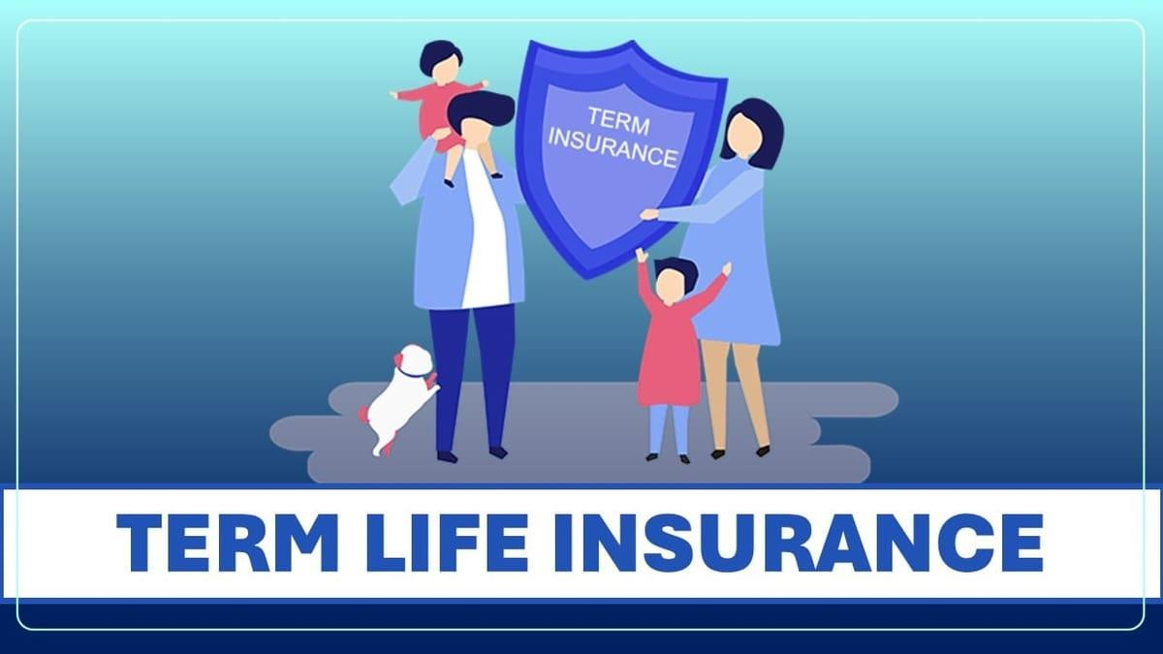

# REASEARCH AND GATHERING OF INFORMATION:-

**COVERAGE :-**

**Diseases covered under health insurance :**

* **Ambulatory patient services**
* **Cashless claim benefits**
* **Critical illness**
* **Accident**
* **Emergency care**

**Diseases covered under Term-Life insurance :**

* **Critical illness insurance**
* **Tax**
* **Life cover**
* **Disability**
* **Financial protection**
* **FINANCE**
* **Finance**
* **Flexible payout options**
* **Affordable premiums**
* **Term life insurance**

# BENEFITS:-

**Benefits of health insurance**

* **Covers hospitalisation expenses. …**
* **Covers pre-and post-hospitalisation expenses. …**
* **Covers daycare procedures. …**
* **Covers domiciliary treatments. …**
* **Covers alternative treatment. …**
* **Covers annual health check-ups. …**
* **Offers add-on cover for critical illnesses. …**
* **Offers cashless treatment.**

**Benefits of term- life insurance**

* **Critical illness insurance**
* **Whole life cover**
* **Tax**
* **Accidental death benefit**
* **Employee benefits**
* **Affordable premiums**
* **Return of premium**
* **Financial security**
* **Premium pay options**
* **Protection from illnesses**
* **Riders**
* **Coverage period**
* **Low entry age**
* **Maturity benefits**
* **Premium waiver**
* **Term life insurance**

# EXCLUSIONS:-

**Commonly there 4 exclusions for health insurance policy , they are:**

* + **Dental, Hearing, and Vision**
  + **Cosmetic surgery**
  + **Pregnancy and related conditions**
  + **Pre-existing conditions**

**4 exclusions for term-life insurance, they are:**

* **Suicide**
* **Acts of war**
* **Service in the military**
* **Aviation accident**

# PREMIUM:-

An insurance premium is the amount of money an individual or business pays for an insurance policy.

» The premium is calculated is based on several factors,

including the time value, intrinsic value, and the underlying security’s implied volatility.

**PREMIUM FOR HEALTH INSURANCE:-**

» premium for health insurance is ₹9,192 for a insurance amount of 50,00,000/- and maturity period is 1 year.

» premium for health insurance is ₹17,109 for an insurance amount of 50,00,000/- and maturity period is 2 year.

» premium for health insurance is ₹25,122 for an insurance amount of 50,00,000/- and maturity period if 1year.

**PREMIUM FOR TERM-LIFE INSURANCE:-**

» Yearly premium for Term-life insurance is ₹4,830 for an insurance amount of 25,00,000/- and maturity period is 15 years.

» Half- yearly premium for Term-life insurance is ₹2,446 for an insurance amount of 25,00,000/- and maturity period is 15 years .

» Monthly premium for Term-Life insurance is ₹413 for an insurance amount of 25,00,000/- and maturity period is 15 years.

* CREATING HYPOTHETICAL SCENARIOS:-

Creating hypothetical scenario for HEALTH INSURANCE.

## “Health insurance for SENIOR CITIZENS”.

»»» Health insurance policy for senior citizens gives a FINANCIAL BACKUP AT THE TIME OF NEED. Senior citizens

are more likely to develop illnesses and treatment costs which may be high. Senior citizen health insurance policy covers you against such medical expenses.

## “Health insurance for YOUNG ADULTS”.

»»» Standard health insurance plans come with an upper age limit of 60-65 years. The premium amount rises if you buy a plan after this age limit as it is a senior citizen health insurance plan. Therefore, it is advisable to buy health insurance at an early age and AVOID PAYING HIGHER PREMIUMS LATER IN YOUR LIFE.



***Creating hypothetical scenarios for Term- life insurance:-***

## Term- life insurance policy for millennia’s .

***Of millennials who have life insurance, the majority got it to help with end-of-life costs such as funeral and burial expenses. The other main reason for investing in life insurance was to support family living expenses, provide money for children, and alleviate debt.***

## Term- life insurance for Young person.

It can help you not pass on debt to your loved ones. Life insurance can make sure that student loan debt,

mortgages, and any other large debts are not passed on to the loved ones you leave behind.

# DIFFERENCE BETWEEN TERM LIFE INSURANCE POLICY AND HEALTH INSURANCE POLICY :-

There are a few factors that state the difference

between term insurance and health insurance plans.

Factors Term Insurance Health Insurance

|  |  |  |
| --- | --- | --- |
| Objective | A term insurance plan will provide a life  cover that will offer the lump sum death benefit to your loved ones in case of your unexpected death.  Your family can utilise it for various financial objectives such as paying off debts,  accomplishing future financial  commitments, etc. | A health plan Is used to pay for your hospital bills and other related medical expenses based on your health conditions and other treatments. |
| Benefits | With a term plan, you can receive a life  cover, add-on rider# benefits, and the  return of premiums2 | With a health insurance plan, you will receive a financial benefit  to manage your |

|  |  |  |
| --- | --- | --- |
|  | on maturity. You can also customise the plan based on your financial needs. | treatment expenses based on the bills charged by your doctor in the  hospital. |
| Taxation | The premium amount paid towards your term plan will qualify for a tax* deduction under Section 80C upto ₹1,50,000, and the payouts will qualify for the tax* exemption under  Section 10(10D) of the Income Tax Act 1961. | The premium paid towards your health insurance plan will qualify for a tax*  deduction under Section 80D of the Income Tax Act, 1961. The  deduction can be upto ₹25000 for an individual and upto ₹50,000 for a  senior citizen. |
| Add-on Options | Apart from the life  cover, you can choose additional riders#  such as the critical illness rider# to pay the insured sum for your hospitalisation and other medical  bills in case you get | You can extend the health insurance  benefits based on your family  requirements by adding maternity cover, newborn |

|  |  |  |
| --- | --- | --- |
|  | affected due to a critical illness during  the policy term. | cover, OPD cover, etc. |
| Maturity | There is no real | In a health |
| Benefit | maturity benefit in | insurance plan, |
|  | term insurance plans. | you can receive a |
|  | However, you can | no claim bonus |
|  | choose to get the | that will reduce |
|  | return of premium2 | the premium by a |
|  | paid at the end of the | certain |
|  | policy term, which will | percentage if you |
|  | serve as a savings | have not filed a |
|  | benefit. | claim in the  previous year. |
| Policy duration | You can choose a | Regular health |
|  | longer policy duration, | insurance plans |
|  | up to 40 years, to | have a 1-year |
|  | leave a strong legacy | policy tenure. |
|  | of financial support |  |
|  | for your loved ones. |  |

* **CONCLUSION :-**

**Term insurance and health insurance are two different products that extend their financial support in an emergency. Term insurance plans provide a life cover, add-on riders#, and the return of premium2 options. A health insurance plan will provide a fund to pay for your medical bills and other hospitalisation charges.**

**The premium amount of the term insurance is minimal and affordable to the most. However, the premium for health insurance is costly, particularly after a certain age. It is advisable to avail the health insurance when you are healthy and young.**

**Term life insurance is the most popular type of life insurance. It is widely considered to be the simplest and purest form of life insurance. It offers a death benefit to the**

**beneficiaries of the policy if the policyholder passes away during the policy term.**

**BY**

**Jeevan kumar marlapudi**

**DR LANKAPALLI BULLAYYA COLLEGE**

**ANDHRA UNIVERISTY**

**ACCOUNTING AND FINANCIAL ANALYSIS.**